Question 1 - Convolution

🡺 fspecial("laplacian", 0.5)

This filter finds edges in the given photo.

🡪 Zero Padding 🡪 Border Padding

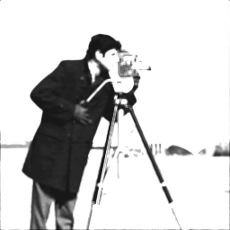 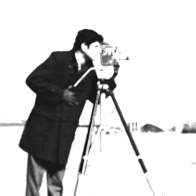

🡺 fspecial("gaussian", 5, 5)

This filter removes noise and details by giving blur to image.

🡪 Zero Padding 🡪 Border Padding

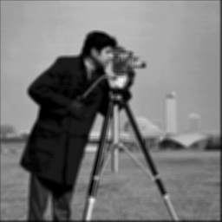 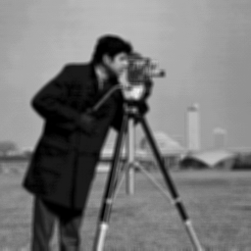

🡺 fspecial("sobel")

This filter emphasizing the edges of given picture.

🡪 Zero Padding 🡪 Border Padding

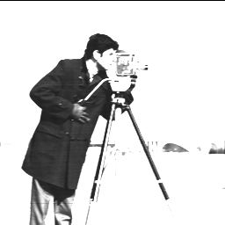 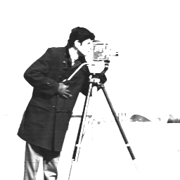

🡺 fspecial("motion", 40, 135)

Filter generates a highly blured image.

🡪 Zero Padding 🡪 Border Padding

